**Nose Cone Separation Ring for LV3 High Altitude Sounding Rocket**

**Miles Atherly, Benjamin Butler, Andrew Eads, Jason Hamilton, Brian Happ, Alin Resiga**

**Advisor: Dr. David Turcic**

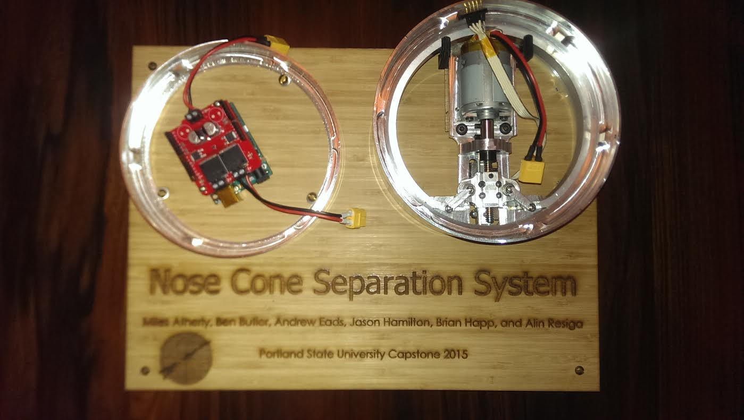



**Executive Summary**

An electro-mechanical Nosecone Separation Ring (NSR) system was developed for Portland State Aerospace Society (PSAS). The electro-mechanical NSR will replace PSAS’ current NSR mechanism, which uses a bonding agent and gunpowder charges. The new NSR will address several shortcomings exhibited by the current separation device.

The electro-mechanical NSR uses a DC motor, linear guide rail, ¼-16 ACME power screw, and relative motion arms, guide pins, and rails to actuate an aluminum v-shaped clamping band over two angled surfaces A wave spring, which provides a kickoff force upon separation, is inlayed into a groove in the larger (male) coupling ring. Currently, the prototype NSR is controlled by pulse width modulation (PWM) via an Arduino Uno R3. Two limit switches control fore and aft travel of the sled during actuation, and cut the power to the motor. In its current design state, the NSR is capable of deploying in less than 63 milliseconds.

Physical testing, finite element analysis, and mathematical models were used to verify reliability of critical components in the new NSR system. The most critical component, which also bears the highest stress during actuation, is the aluminum clamping band. The design of the band was optimized so that it has a minimum factor of safety of 1.67 throughout the actuation.

Table of Contents Page

1. Introduction X
2. Mission Statement X
3. Main Design requirements X
4. Top-Level Design Decision
5. Final Design X
6. Evaluations of Components
   1. V-Band Sizing and Analysis
   2. Clamped Surface Analysis
   3. Motor Sizing X
7. Evaluations as Related to PDS X
8. Conclusions and Recommendations

Acknowledgements

Bibliography

Appendix A: Detailed Design

Appendix B: DFMEA on V-band

Appendix C: Potential Yielding at Critical Point

Appendix D: Bill of Materials

Appendix E: Analysis Based Design Decisions

Appendix F Assembly Instructions

Appendix G: Drawings

**1.0 Introduction**

Portland State Aerospace Society (PSAS) was founded in 1997 with the goal of putting a nano-satellite into orbit. PSAS is in the process of building their third sounding rocket, and is redesigning several aspects of this rocket, including the nose cone separation mechanism. Currently, the nose cone is adhered to the main body of the rocket with epoxy. A small amount of gunpowder is deposited throughout a cavity between the nose cone and body. At apogee, the gunpowder is ignited via electric matches, breaking the bond of the epoxy. An internal plunger assembly then pushes the nose cone off the rocket, deploying the parachute. This separation method is not easily testable, but does allow the rocket to be recovered and reused. PSAS would like an easily testable, reliable, and more efficient way of releasing the nose cone and deploying the parachute. Ideally, the new parachute deployment mechanism would be easy to reset and not use any consumables, such as gunpowder.

Four main separation mechanisms were used to draw ideas from. A Marmon clamp, a LightbandTM, gas actuated pins, and an electromagnetic lock. An electro-mechanical device similar to the Marmon Clamp, and the V-Band, was chosen for its simplicity and reliability. The design relies on the expansion and contraction of an angled band to clamp the upper and lower rings of the rocket together. This device increases the diameter of the clamping band using a power screw driven by a motor. Since the power screw is self-locking, the two rings stay clamped without additional power. The motor reverses the direction of the power screw, and the rings become unclamped in under 63 milliseconds. The electro-mechanical NSR meets all of the design requirements; it is easily resettable, easily testable, and will withstand the forces it will experience in flight.

**2.0 Mission Statement**

The mission of the NSR team was to design and prototype a device that will facilitate the separation of the nose cone from the main body of the rocket. The device needs to be easily testable, resettable, and have a failure rate of less than one percent. The device must not impede the parachute deployment, and needs to be completed by June, 5, 2015 with a budget of $3,000.

**3.0 Main Design Requirements**

The current NSR cannot be tested without firing the gunpowder charges which makes it difficult to predict if the separation ring has been prepared correctly before launch. The epoxy used to bind the nose cone to the body takes several hours to cure, so if any problems are detected before launch they cannot be corrected on the same day. PSAS would like to replace their existing NSR with an electro-mechanical device that can be tested, easily reset, and have a verifiable failure rate of less than one percent. This would allow them to check the NSR mechanism on launch days. If the device were to fail, it needs to fail in the closed position (i.e.-the nose cone remains attached to the airframe in the event of system failure). This is significantly safer than failing in the open position (i.e- the nose cone is detached from the airframe in the event of system failure)

The NSR should use no more than 5W of standby power and no more than 50W of power to actuate from the main battery. The device also needs to be operable in a vacuum, and withstand a tensile force of 250lb PSAS requested, but did not require that the design of the NSR be modular and scalable so that it can be adapted for stage release applications and for larger diameter rockets in the future.

**4.0 Top-Level Design Decision**

The three main concepts that were pursued were an electro-mechanical device driven by a stepper motor, a compressed gas powered 4- pin actuator, and an electromagnetic lock. The gas powered 4-pin actuator was discarded due to difficulties designing it to fail in a closed position. An electromagnetic lock design was quickly discarded because the magnets could be damaged upon touchdown impact. Ultimately, the decision was made to use a clamp similar to the V-band and Marmon clamp driven by a DC stepper motor. Later, the stepper motor was replaced with a brushed DC motor as it is easier to manipulate, can be over-driven, and will satisfy the speed and power requirements of the proposed design.

From the external and internal search, a concept scoring matrix was used to decide between alternative ideas. The results are summarized in Table 1. The V-band has the highest score, and was used as a starting point for the NSR design.

Table 1. Concept Scoring Matrix: Larger numbers correspond to more desireable qualities

|  |  |  |  |  |
| --- | --- | --- | --- | --- |
|  | **V-band** | **LightbandTM** | **Gas Actuated Pins** | **Electromagnetic** |
| **Speed** | 3 | 3 | 4 | 5 |
| **Manufacturing Complexity** | 4 | 3 | 3 | 2 |
| **Power System** | 4 | 4 | 2 | 2 |
| **Binding Risk** | 4 | 3 | 2 | 4 |
| **Totals** | **15** | **13** | **11** | **13** |

The primary reason for designing a mechanism similar to the V-band instead of something more similar to the LightbandTM was due to manufacturing complexity. The LightbandTM uses a series of right angle clamps to hold down the upper ring. These clamps are fixed to the bottom with a shear pin. Creating this design would involve sourcing or machining eight to ten of these right angle clamps, and designing a way to fixture them to the lower ring. Having all of these components might also increase the risk of loading failure. For example, the shear pins could break or the top part of the right angle clamp could shear off. The decision was also made to clamp from the inside instead of the more traditional style of clamping from the outside to keep the rocket as aerodynamic as possible. Figure 1 is a cut-away model of the design where some of the design aspects are seen..

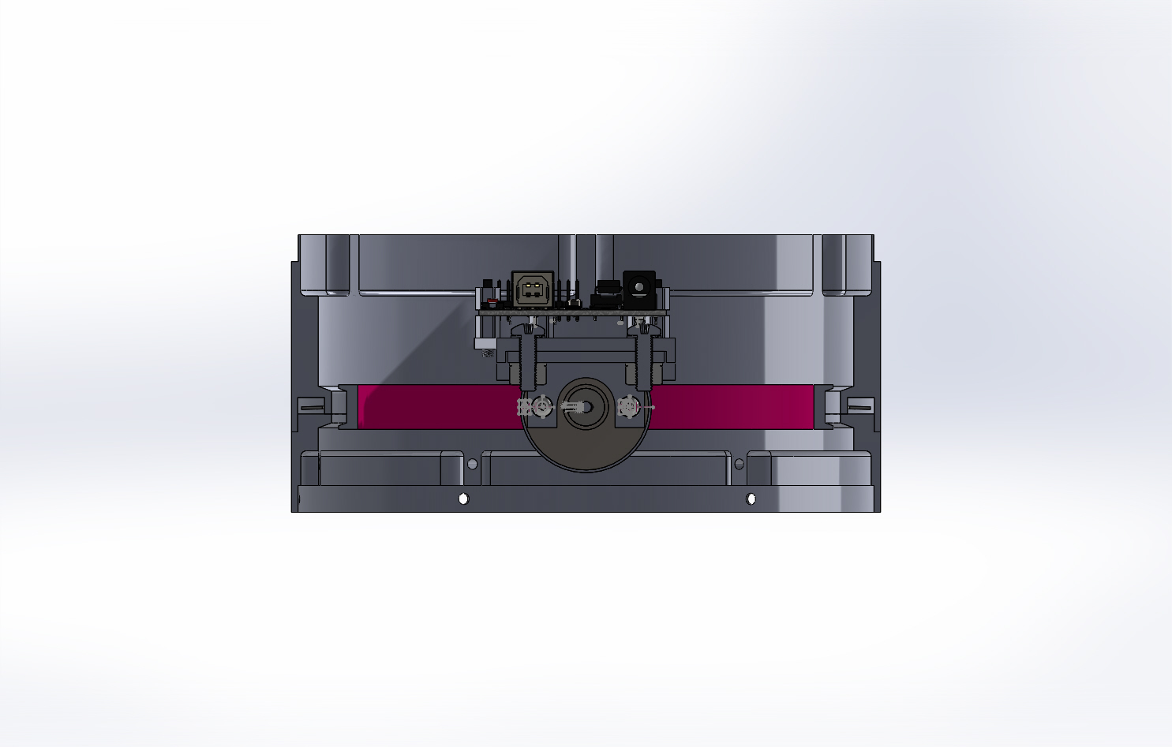

Figure 1- An isometric cut-away view of the initial design proposal. The design incorporates aspects of both the Marmon Clamping System and the LightbandTM separation device.

The NSR design utilizes an internal inverted marmon clamp. The actuation of the inverted marmon clamp works similarly to the LightbandTM in that the actuation is started by translating rotational motion from a DC motor into linear motion. The similarities between the two devices end there, as the NSR’s clamping mechanism significantly differs from that of the LightbandTM.

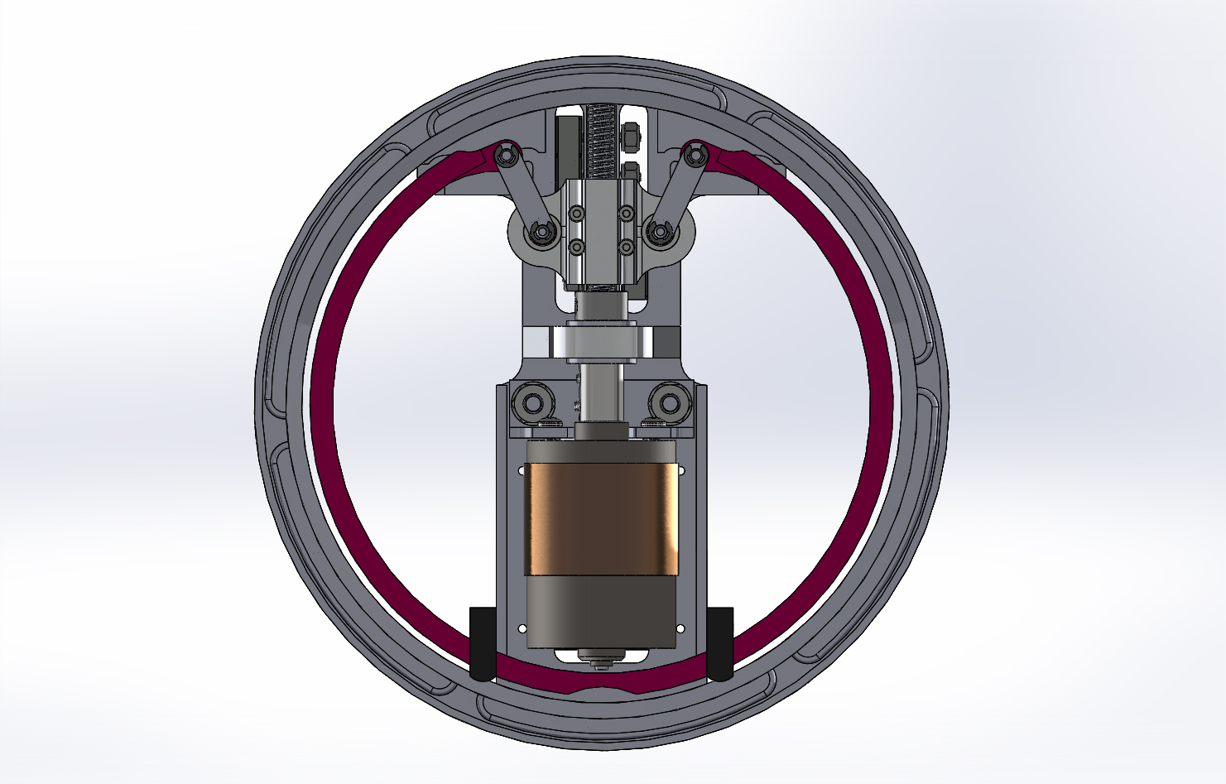

Figure 2- Top down view of the separation mechanism.

**5.0** **Final Design**

The purpose of the mechanism is to provide a clamping force from the V-band simultaneously to the upper and lower rings to hold the nose cone to the rocket during flight. Then, at the desired point in flight, release the nose cone and deploy the parachutes by rapidly contracting the V-band. The nose cone is attached to the upper coupling ring (female) and the main body of the rocket is attached to the lower coupling ring (male).

The NSR mechanism is powered independently by an 11.1 V Lithium Polymer battery. Actuation is started by sending a signal from the flight computer to the control board which powers the motor and drives the V-band to either an open or closed position. The power screw rides on and is supported by the journal and a pair of needle thrust bearings. The sled rides back and forth along the power screw, which provides two important functions; direct horizontal motion for sliding the V-band forward or back to either clamp or release the nose cone, and to actuate the relative motion arms to open or contract the V-band.

During the clamping or unclamping sequence, the sled will contact one of two limit switches mounted under the device. The limit switches signal the control board to stop the motor and end the actuation sequence. The actuator is attached to the upper, larger, coupling which will be attached to the nose cone. Upon deployment, the actuator will separate from the rocket body with the nose cone, allowing plenty of space for the drogue and main parachutes to deploy through. Figure 3 is a bottom up view of the complete NSR mechanism. Not pictured are the arduino and the battery.

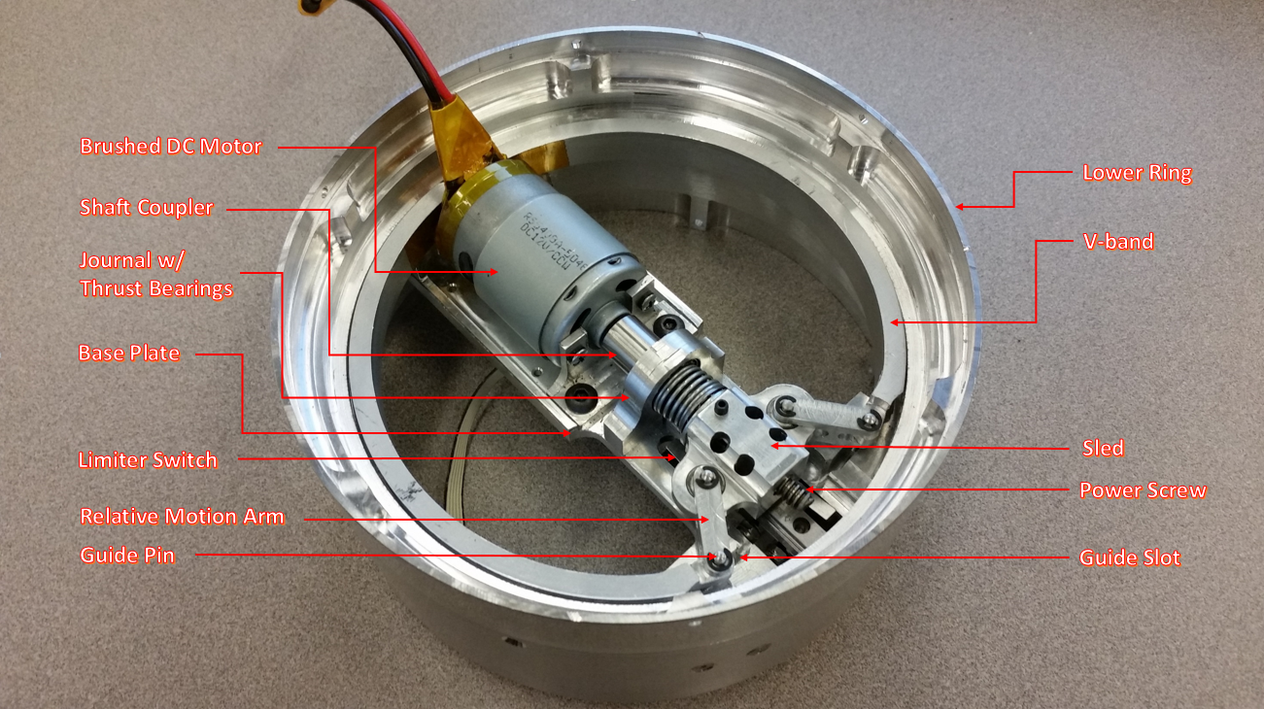

Figure 3: A bottom up view of the complete NSR assembly.

The NSR components are a combination of in-house custom manufactured components and prefabricated outsourced components. The in-house manufactured components include both coupling rings, V-band, journal, shaft coupler, sled, motor mount, dowel pins, male indexing tabs, and actuator arms. The outsourced parts include the power screw, thrust bearings, 7mm guide rail, 7mm carriage, motor, control board, LiPo battery, wave spring, and all fasteners.

**6.0 Evaluation of Components**

After the final design concept was approved, three major design points of the NSR were evaluated. The three design points are the V-band, the clamped surface area of the coupling rings, and the power requirements of the system.

**6.1 V-Band Sizing and Analysis**

A mathematical model constructed using Castigliano’s theorem, shown in Appendix E,shows that the force required to displace the tabs of the band depends heavily on the radius of curvature and the cross-sectional area of the band. The force required to displace the band will be reduced by increasing the radius of curvature of the neutral axis, or by decreasing the cross-sectional area of the band. The original V-band design required a load of 10 lbf per side (20 lbf total) to achieve a net displacement of 0.8 in.

To determine the stress present in the displaced state of the V-band, an FEA model of the band was built and subjected to a similar load. Meshing properties of the FEA model were adjusted until the force and displacement parameters of the FEA model resembled the force and displacement parameters for the mathematical model. Additionally, a physical experiment was performed in order to validate the results of both the FEA and the mathematical mode, shown in Appendix C. Results from the physical experiment matched results from the FEA model and the mathematical model closely, and the FEA model was deemed as a viable design tool for optimizing V-band parameters.

FEA analysis of the original V-band exhibited a maximum stress value of 36.98 kpsi located on the back side of the band on the lip of the clamping surface illustrated in Figure 4. Since the yield strength of 6061-T6 aluminum is 40 kpsi, the original V-band design had a factor of safety of 1.08 in its deployed state. A design revision of the V-band was done in order to increase the factor of safety of the band in the deployed state as well as decrease the force required for displacement. FEA was used as the primary design tool in this process.

The cross-sectional area of the V-band was thinned out significantly by removing material from the web and the lips of the clamping surface. The center of the V-channel was held constant in order to shift the radial distance of the neutral axis outwards. Thinning the web and removing material from the lips of the clamping surface reduced the force required to displace the band from 20 lbf to 6.6 lbf, but did not significantly reduce the maximum observed stress value. 1.5 in diameter relief cut was added to the back wall of the V-band where the maximum stress was observed. The addition of the relief cut reduced the observed stress to 23.92 kpsi and increased the factor of safety to 1.67. The completely revised V-band is seen in Fig. 5 and shows the maximum stress concentration location, and magnitude relative to yield strength of the material.

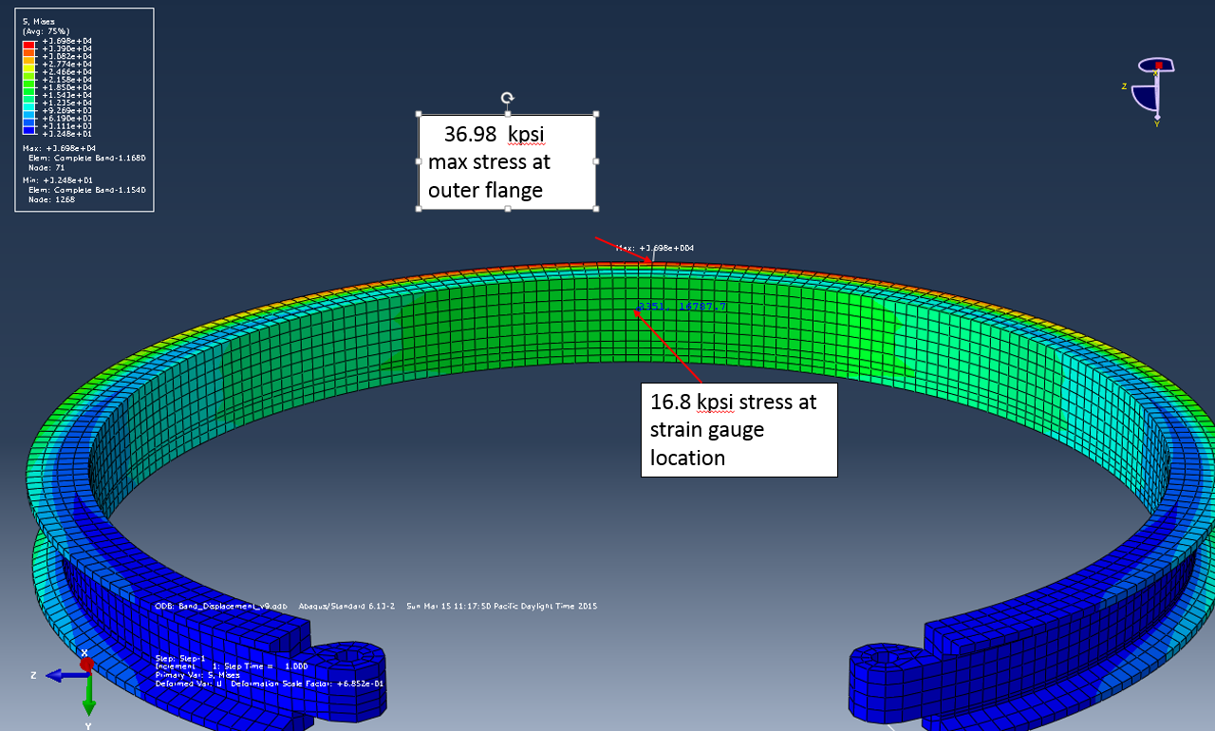

*Figure 4: FEA analysis of the location and magnitude of maximum stress concentration.*



*Figure 5****:***  *Maximum stress relative to material yielding with smaller webbing and a relief cut.*

**6.2 Clamped Surface Analysis**

Figure 6 shows the cross sectional area that the V-band clamps to inside of the coupling rings. The designed cross sectional area was analyzed using an axial load of 250 lbf in order to determine if the clamped surfaces will yield. The minimum theoretical cross sectional area requirement was calculated to be $5.873*10^{-3}in^{2}.$ Figure 6 shows the smallest designed cross sectional area of the clamped surface of $0.0128 in^{2}$ which will not yield at the theoretical axial load and is ideal as the large cross sectional area adds robustness. For the complete analysis of these design dimensions see Appendix E.



Figure 6: Smallest cross sectional clamping area analyzed for yielding

**6.3 Motor Sizing**

To accurately size the motor, a torque test on the power screw was performed. To determine the amount of radial deflection the power screw will experience under specific torque loads, and to develop a method to characterize a torque curve for the power screw, a strain analysis was performed on a ¼” steel rod similar in size and material to that of the power screw. The ¼” rod stock seen in Figure 7 with the attached strain gauge was used in lieu of the power screw due to size and shape constraints for applying the available strain gauge to the power screw. The validated torque testing method was then going to be applied to the power screw to determine the maximum torque needed to actuate the V-band. However, the strain gauge method was not used due to difficulties in applying a strain gauge to the turned down ⅛” round end of the power screw. The maximum torque required to actuate the V-band was determined to be to be approximately 3 in-lb. The maximum torque was found by measuring different loads applied to the end of a radial arm which was attached to the power screw in the prototyped model. The load required during the last 1/8th turn of the power screw was taken to be the maximum required torque. The maximum determined torque value was multiplied by safety factor of to 2 to ensure the selected motor had enough capacity to actuate the V-band within the time limit outlined in the PDS.

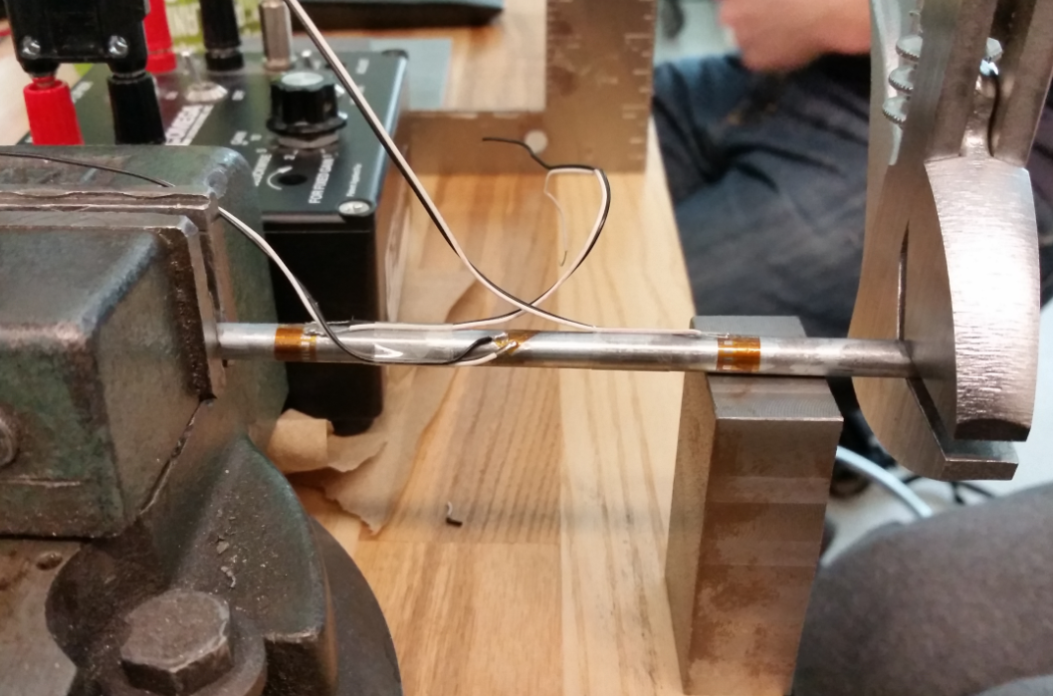

Figure 7: Torque testing on the ¼” rod stock used to validate the torque testing method.

**7.0 Evaluations as Related to PDS**

The main requirement from PSAS is that the system can be easily reset and quickly tested. The design meets this requirement, and can be actuated and reset several times per minute. The device has an actuation time of 63 milliseconds.

By designing the NSR such that the motor and baseplate assembly are attached to the nosecone, two requirements were met. The parachute can deploy without interference from the device, and there is now room to attach an independent battery. The device requires no power from the main rocket battery, satisfying the power requirements outlined in the PDS.

Using FEA, both loading requirements were verified. See Appendix C for the results. The inside band can withstand the 250lb tensile force with a factor of safety of 30.

As seen in Appendix C, the stress on the V-band is 24 ksi at full actuation. According to Equation 1, the V-band can be fully actuated and brought to rest 44,000 times before being affected by fatigue.

|  |  |
| --- | --- |
| $N=[2,100,000/(S-14,000)]^{2}$ | (1)[9] |

Where N is the number of cycles until failure and S is the stress on the part (24 ksi).

The budget for this project was $3,000. Because most of the machining was done in-house, the final product was made at a fraction of the total budget. The final cost of production was $1,300.

**8.0 Conclusion and Recommendations**

An alternative NSR device that does not use consumables, such as epoxy and gunpowder, was developed by the June 5th deadline for a total cost of $1,300. The system utilizes a unique internal V-band design to apply a clamping force to two customized coupling rings that will be mounted on the LV3 rocket. The new NSR is robust in design. FEA shows that the NSR will be able to sustain tensile loadings of up to 250 lbf with a factor of safety of 30. Fatigue analysis on the V-band shows that it will sustain 44,000 cycles of actuation before failure. The actuation time of the NSR is 63 milliseconds (conservatively), so the device can be tested and reset several times a minute. The system is equipped with its own power source and will not draw more than a nominal amount of power from the main rocket battery. The system is designed to fail in the closed position as requested.

Designing the electro-mechanical NSR presented several unique challenges. The size of the LV3 rocket modules limited the type of actuators that could be used. Designing a clamping system that utilizes bending in key components is unorthodox in nature. The power requirements of the system were such that a custom drive train had to be designed and machined.

A prototype electrical system utilizing an Arduino Uno R3 and a 30 Amp H-Bridge was developed to test the new NSR system. Controlling the system for position and speed has proven to be difficult due to the extremely fast wind up of the motor and the small linear displacement of the actuator. The stall current of the motor is 85 Amps and the no load speed of the motor is 19300 RPM. The use of the 30 Amp H-Bridge limits the motor from operating over its full torque range. The lack of low end power due to the 30 A current ceiling sometimes causes the system to become bound in the forward position. Additionally, the sampling rate of the Arduino Uno is limited to 9600 samples per second. When the NSR is actuating, the motor spins up so fast that the system has a tendency to overshoot the fore and aft limit switches before the power to the motor is braked to the ground pin of the Arduino. This makes the system very difficult to precisely control. The system would benefit from using a faster control board that is not limited to an amperage below the motors stall current. Additionally the NSR system would benefit from a second type of feedback other than limit switches to avoid binding in the forward or reverse position. A pressure sensor, force transducer, proximity switch, or a more advanced position detection system could be implemented to improve the performance and reliability of the device.

**Acknowledgements**

The Nosecone Separation Ring group would like to give special acknowledgement to Jeffrey Hickman, Dr. Turcic, Mike Chuning, Andrew Greenberg, Nathan Bergey, Gavin Gallino, Sam Stewart, and all the members of PSAS for their support in this project.

**Bibliography**

[1] Budynas, Richard G, J K. Nisbett, and Joseph E. Shigley. *Shigley's Mechanical Engineering Design*. New York: McGraw-Hill, 2011. Print.

[2] Dailey, J., 2014. *AFRL Technology Demonstrated on NASA Moon Mission.* [Online]

Available at: http://www.wpafb.af.mil/news/story.asp?id=123418650

[Accessed 8 January 2015].

[3] Dirgo, B., 2013. *Orbital Sciences Corporation Payload Separation System.* [Online]

Available at: http://www.cefns.nau.edu/capstone/projects/ME/2014/OrbitalPayloadSeparationSystem/images/carosel_images/4_new.png

[Accessed 25 November 2014].

[4] Lazansky, C., 2012. *Refinement of a Low-Shock Separation System,* s.l.: s.n.

[5] NASA, 1970. *Flight Separation Mechanism,* s.l.: s.n.

[6]NASA, n.d. *Marman Clamp System Design Guidelines,* s.l.: s.n.

[7] NEA Electronics Inc., n.d. *Ensign-Bickford Aerospace & Defense.* [Online]

Available at: http://www.eba-d.com/assets/product-sheets-nea/V-Band-Product-Sheet.pdf

[Accessed 8 January 2014].

[8] Sierra Nevada Corporation, n.d. *Qwksep Payload Separation System.* [Online]

Available at: http://www.spacedev.com/pdfs/Qwksep%20Payload%20Separation%20System.pdf

[Accessed 8 January 2015].

[9] Yahr, G. T., 1993. *FATIGUE DESIGN CURVES FOR 6061-T6 ALUMINUM,* Oak Ridge, Tennessee: Oak Ridge National Laboratory.

**Appendix A: Detailed Design**

The LV3 launch vehicle is composed several modular sections that have an inner diameter of 6 inches and an outer diameter of 6.6 inches. The inner diameter of the modular sections was a major design constraint and was used as the starting point for the NSR design. Castigliano’s theorem shows that for a curved beam, the force required to deflect the beam a set distance is dependant on the radius of curvature of the neutral axis of the beam and the cross-sectional area of the beam. Castigliano’s theorem was initially used to design the V-band such that the force required to actuate the band within the 6 inch diameter modules would be at a minimum. The clamping surfaces onto which the V-band mated were fixed at 5.7 inches in diameter. A 20 degree angular clamping surface was decided upon, because the angled surface helps guide components into proper placement during mating. The height of the V-band was fixed at 0.5 inches. Single part FEA of the V-band and the clamping surfaces showed that all surfaces could sustain t a 250 lbf tensile load with a factor of safety of 30. FEA was later used to optimize sizing parameters of both the V-band and the coupling ring clamping surfaces.

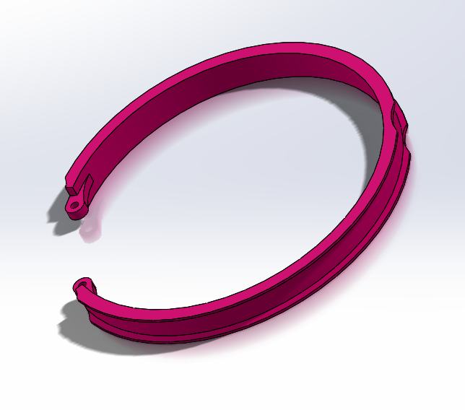

Figure 1A- Final V-band design.

Actuation of the V-band requires that a pair of equal and opposite forces be applied to the two tabs of the V-band. In order to accomplish this, a linear actuator needed to be designed. FEA, Castigliano’s theorem, and real world experimentation showed that a minimum force of 8 lbf per tab was needed to actuate the band. The force requirement combined with the space constraints of the LV3 modules immediately disqualified many traditional prefabricated linear actuators. In order to satisfy the power requirements of the V-band, a high powered brushed DC motor and custom linear actuation mechanism were needed.

A power screw was selected as a the preferred method of translating rotational motion to linear motion. In order to keep the torque on the power screw low, a small diameter (0.25 inch) screw was selected. A 7mm precision guide rail and carriage was selected to provide a linear motion constraint to the actuation system. The guide rail is made out of hardened steel and has a dynamic load capacity of 300 lbf. A sled and arm assembly which interfaced with both the carriage and the V-band tabs was designed to transmit the force from the DC motor to the V-band. During actuation, the arms of the sled are allowed to rotate. The sled was fitted with ⅛” ID x ⅜” OD x 5/32” height ball bearings which limit the friction incurred in the arms during actuation.

In order to mate evenly around the entire clamping surface, the center of the V-band must be held constant while the diameter of the band increases. This was accomplished by designing a set of relative motion channels which constrain the motion of the V-band tabs (and sled arms) to a set path. The principles of rigid body kinematics were used to describe the path the arms were required to follow in both rotation and translation.

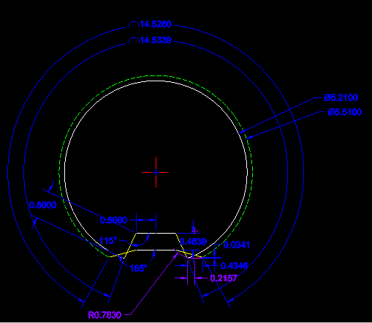

Figure 2A- A graphical representation of the V-band in its “open” and “closed” state. The initial and final angle of the relative motion arms (yellow), and sled (white) are shown. Additionally, the V-band perimeter is shown (solid white, dotted green).

A theoretical torque curve for the entire system was modeled using the required actuation force, sled dimensions, rail dimensions, and power screw dimensions. The model predicted that 6 lbf-in of torque was needed to actuate the power screw. The net linear distance traveled by the sled to accommodate full actuation was found to be 0.4636 inches. This distance corresponds to just over 4 complete rotations of the ¼-16 ACME power screw. A motor that was capable of delivering the determined torque requirements as well as the goal actuation time of 0.1s was selected. The dimensions of the selected motor allowed for direct drive of the device.

A base plate was designed to incorporate all of the above mentioned elements as well as two slots for limit switches. The base plate bridges the 6 inch diameter of the coupling rings for added strength and stability. Single part FEA of the baseplate showed that it could sustain a 250 lbf concentrated load applied to the part center. The base plate design also includes a 1.5” x 1.5” pattern of 4-40 tapped mounting holes onto which a control board or control board adapter can be mounted. The base plate is held in place with seven 4-40 tapered machine screws which interface with the coupling rings. A modular stem was designed to mount to the bottom of the baseplate. The modular stem adds additional structural stability as well as providing a surface onto which limit switches and other feedback mechanisms can be mounted.

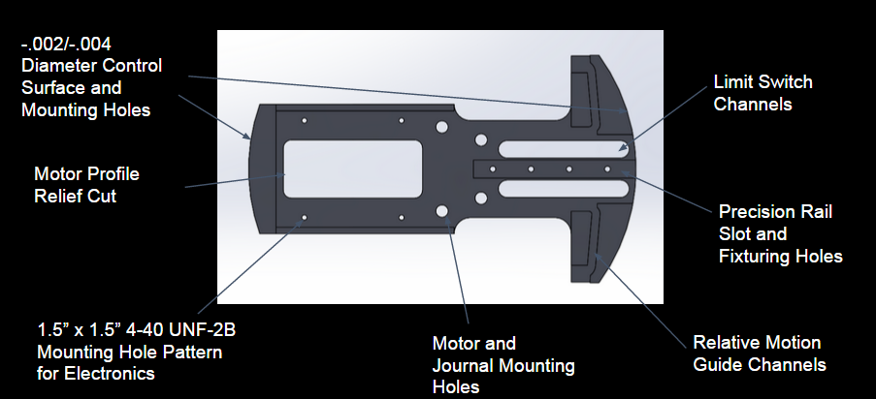

Figure 3A- Baseplate design showing many of the mentioned design features.

A pair of custom coupling rings was designed to interface with the NSR actuator and V-band. The male coupling ring is indexed with three female half inch alignment grooves around the surface which mates to the female NSR coupling ring. The female coupling ring contains 3 male tabs which interface with female grooves as well as holding a wave spring in place. The wave spring provides a kick-off force of approximately 88 lbf upon actuation. Both coupling rings have an outer diameter of 6.6 inches and an inner diameter of 6 inches outlined in the PDS. The coupling rings also exhibit the same internal structural features as the standard LV3 coupling ring modules and can thus be fitted to any standard LV3 coupling ring. This allows the NSR device to later be adapted to stage separation if PSAS decides to do so.



Figure 4A- A cutaway view of the NSR assembly including coupling rings and wave spring.

A prototype control system utilizing an Arduino Uno R3, a pair of limit switches, a button and a Monster Moto H-Bridge was developed for testing and demonstration purposes. The control system continuously samples a set of input pins for a state change to occur in the button. If a state change is sensed, the controller checks the status of each limit switch to determine the current position of the V-band. When the position has been detected, the controller then drives the motor in the direction needed to move the band toward the opposite limit switch. The controller then monitors the input pins for a second state change corresponding to the activation of the new limit switch. When the switch has been activated, the control board brakes the motor to the ground pin of the motor shield and control board.

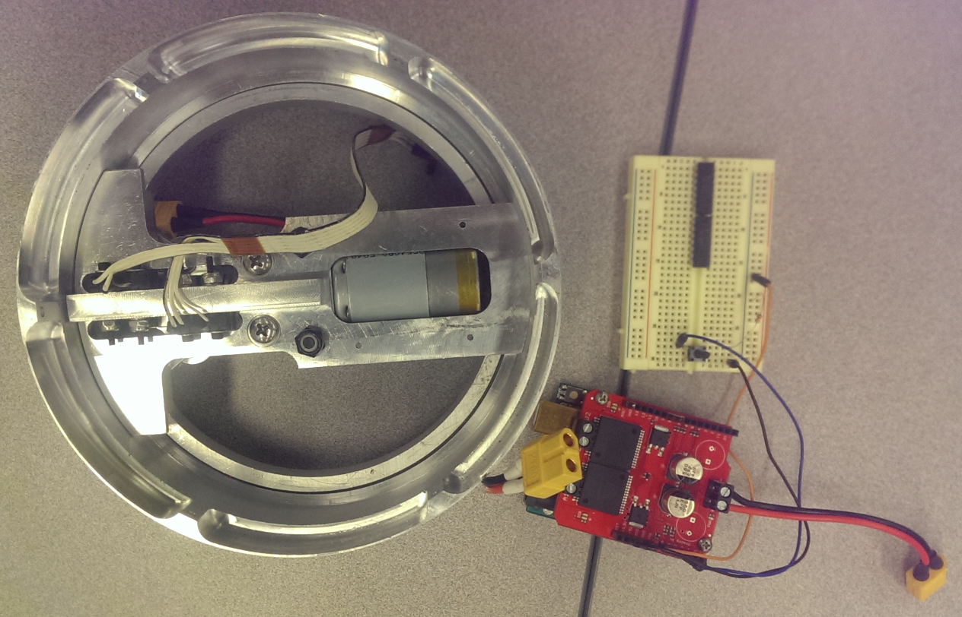

Figure 5A- Prototype control system of the NSR.

**Appendix B: DFMEA on V-band**

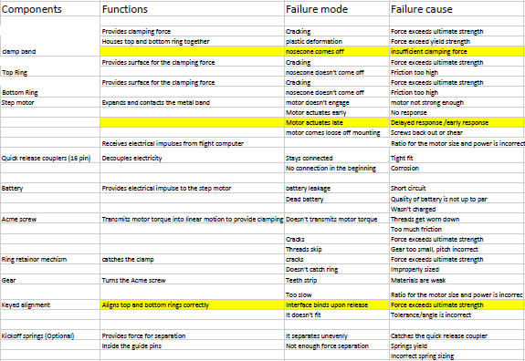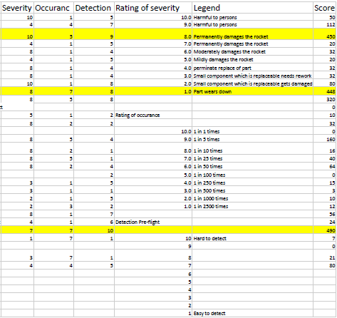

Figure 1B: The DFMEA on the V-band which shows the three most critical failure modes.

**Appendix C: Potential Yielding at Critical Point**

A circular aluminum clamping mechanism (V-band) was tested to determine the force required to displace the band. A strain gauge was also mounted to the inside of the band to measure stress at a critical location. This location was chosen because it was determined as the most critical point in the V-band. Stresses and displacements in the band were analysed prior to conducting the experiment using Abaqus Finite Element Analysis (FEA) software. The software was also used to determine the force required to displace the V-band to the maximum diameter. This testing was important due to the requirements brought by the PDS. The PDS requires the NSR to be quick to reset and quick to test, therefore the FEA software will tell the group the required forces and any possible yielding stresses in order to clamp the rings fully.

The dimensions, material, and change in clearance was known. The force and stress at critical points required to change the clearance 0.8 inches is desired to be known. There were three methods which were used, FEA half band, FEA full band and Castigliano's method. The main assumptions made were to try either the half band or the full band. The results showed to be closed to the actually readings as depicted in Table 1C. The experimental schematic could be seen in Figure 1C. While the two FEA analysis were depicted in Figure 2C.

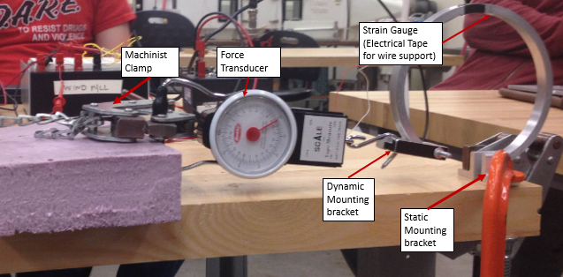

**Figure 1C:** The fixtures and apparatus of the experiment: note that the force exerted on the dynamic end of the V-band was in-line with the static end; i.e. the motion was constrained in one dimension. See appendix A for more details

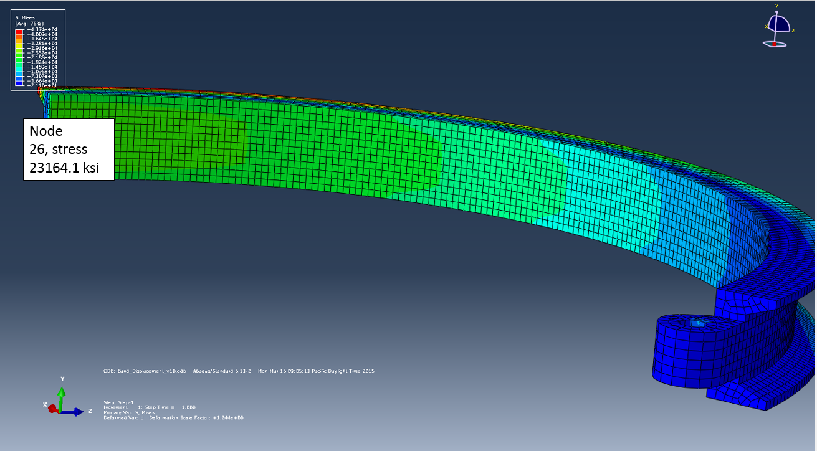

**Figure 2C:** FEA analysis of the half band shows the stress at the strain gauge.

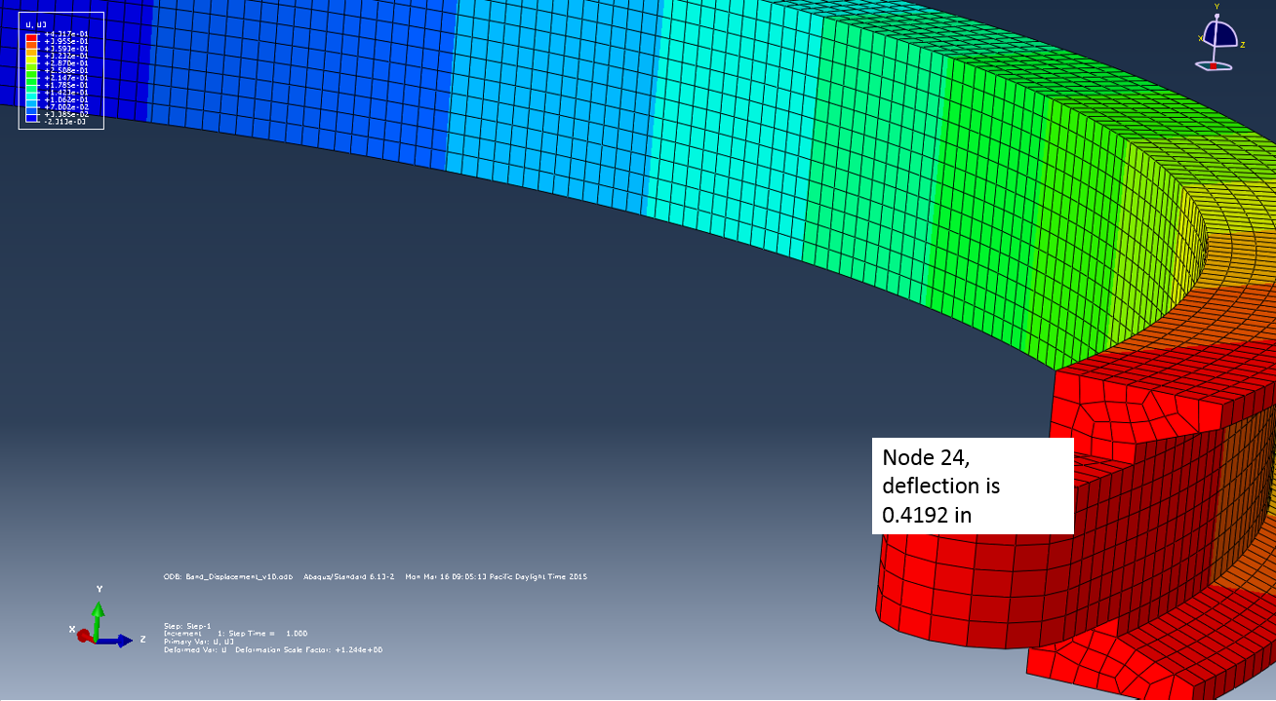

**Figure 3C:** The FEA analysis shows the deflection of the dynamic mounting bracket.

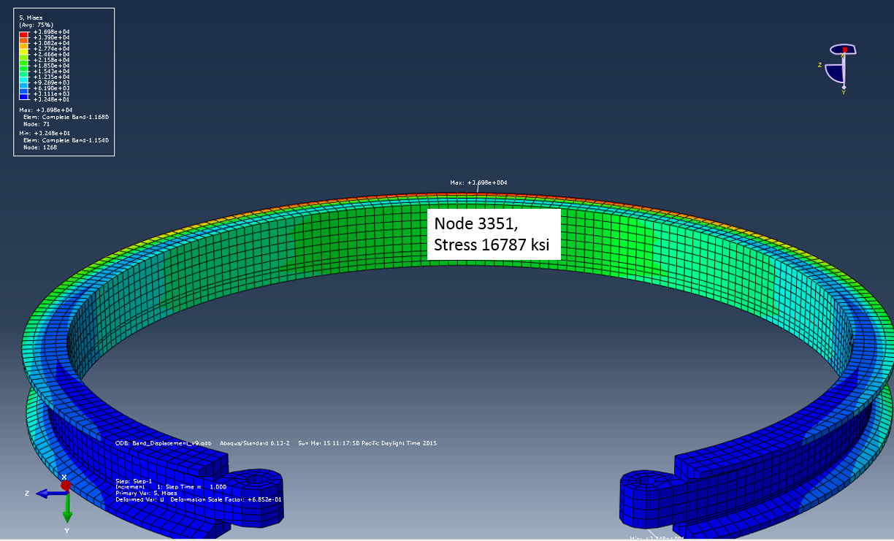

**Figure 4C:** The FEA analysis shows the stress of the full model being under 16.7 ksi of stress at the strain gauge.

**Figure 5C:** The FEA analysis shows the amount of deflection at the dynamic mounting bracket.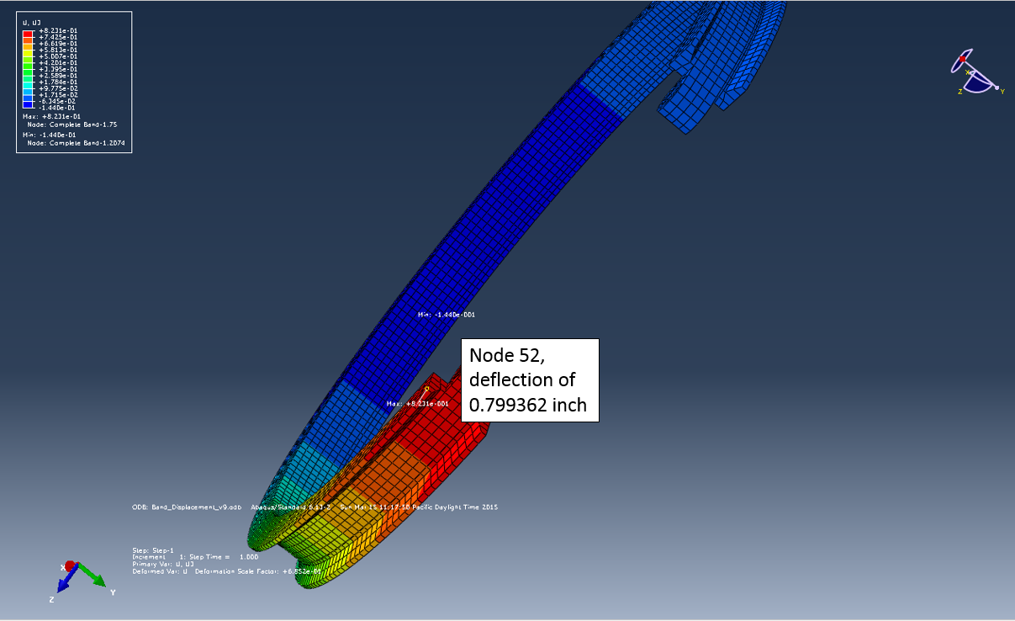

**Table 1C:** The force required and stress generated in deflecting the V-band 0.8 in.

|  |  |  |  |  |
| --- | --- | --- | --- | --- |
|  | Experimental | Castigliano's method | FEA: Full V-band Geometry | FEA: Half V-band geometry |
| Force to deflect V-band 0.8 in. | 20.67 lbf | 15.69 lbf | 20.6 lbf | 15.7 lbf |
| Stress at strain gauge location | 27.90 ksi | N/A | 16.79 ksi | 23.16 ksi |

**Table 2C:** Shows which methods had the lowest amount of error between each other in terms of force (lbf)

|  |  |  |  |  |
| --- | --- | --- | --- | --- |
| Percent error force required for V-band displacement | Experimental | Castigliano’s method | FEA full geometry | FEA half geometry |
| Experimental | 0 | 24% | 0.3% | 24% |
| Castigliano’s method | 24% | 0 | 23.8% | 23.7% |
| FEA full geometry | 0.3% | 23.8% | 0 | 23.7% |
| FEA half geometry | 24% | 0.06% | 23.7% | 0 |

**Table 3C:** Shows which methods had the lowest amount of error between each other in terms of stress (ksi)

|  |  |  |  |  |
| --- | --- | --- | --- | --- |
| Percent error stress | Experimental | Castigliano’s method | FEA full geometry | FEA half geometry |
| Experimental | 0 | N/A | 39.8% | 16.9% |
| Castigliano’s method | N/A | N/A | N/A | N/A |
| FEA full geometry | 39.8% | N/A | 0 | 27.5% |
| FEA half geometry | 16.9% | N/A | 27.5% | 0 |

The full band matched Castigliano's method, however the FEA half band matched the experimental reading better. Error was generated in multiple stages of the experiment. There was error in the readings from two key instruments, the digital caliper and the hanging scale. These instruments had an error of ±0.001 in. and ±0.5 lb. respectively. Over three trials, the average force required to deflect the V-band 0.8 in was found to be 20.67 lbf, which agrees with a comparable FEA model.

**Appendix D: Bill of Materials**

Shown below is a table listing all of the parts that are included in the final assembly.

**Table 1D:** Bill of Materials (BoM) for all parts included in the final assembly

|  |  |  |  |
| --- | --- | --- | --- |
| Part | Description | Location | QTY |
| E clips | 1/8" E clips | Arms / sled, Arms / V-band | 8 |
| M2 x 8mm socket | M2 x 8mm socket screw | Sled assembly | 4 |
| 7mm x 60mm rail | 7mm x 60mm length precision rail | baseplate assembly | 1 |
| 7mm carriage | 7mm clean room carriage | baseplate assembly | 1 |
| 1/8 x 3/8 x 5/32 bb | precision ball bearing | sled assembly | 2 |
| 6-32 set screw | 6-32 x .25 | sled assembly | 1 |
| 1/4-16 x .25 nut | ACME nut, 1/4/16 | sled assembly | 1 |
| sled | custom machined sled | sled assembly | 1 |
| 2-56 x .5 panhead | 2-56 phillips panhead | baseplate assembly | 3 |
| limit switches | snap-action limit switch | baseplate assembly | 2 |
| 3-56 x 1 socket | 3-56 x 1 socket screw | baseplate assembly | 4 |
| 3-56 washer | washer / spacer | baseplate assembly | 8 |
| 3-56 lock nut | 3-56 nylon lock nut | baseplate assembly | 4 |
| modular stem | custom machined stem | baseplate assembly | 1 |
| baseplate | custom machined baseplate | baseplate assembly | 1 |
| .25 x .678 thrust bearing | INA needle thrust bearing, .25 | journal | 2 |
| .25 x .678 thrust washer | INA needle thrust washer, .25 | journal | 2 |
| .175 x .125 coupler | custom machined coupler | journal | 1 |
| .25 collar | shaft collar | journal | 1 |
| 1/4-16 ACME all thread | power screw | journal / drive train | 2.5 in |
| journal | custom machined journal | journal | 1 |
| RS-550 motor | Banebots RS-550 | motor assembly | 1 |
| motor mount | custom machined motor mount | motor assembly | 1 |
| M3 x 6mm | M3 x 6mm machine screw | motor assembly | 2 |
| 10-32 x 5/8 | 10-32 machine screw | actuator assembly | 2 |
| 10-32 x 3/8 | 10-32 machine screw | actuator assembly | 2 |
| 10-32 lock nut | 10-32 nylong lock nut | actuator assembly | 2 |
| relative motion arms | custom machined arms | actuator assembly | 2 |
| dowel pin size 1 | custom dowel pin, size 1 | actuator assembly | 2 |
| dowel pin size 2 | custom dowel pin, size 2 | actuator assembly | 2 |
| V-band | custom machined band clamp | actuator assembly | 1 |
| wave spring | smalley SSR-0637 | coupling rings | 1 |
| index tabs | custom machined tabs | coupling rings | 3 |
| 4-40 x .25 | 4-40 x .25 tapered machine screws | coupling rings | 3 |
| male coupling ring | custom coupling ring | coupling rings | 1 |
| female coupling ring | custom coupling ring | coupling rings | 1 |
| 4-40 x .5 | 4-40 x .5 tapered machine screws | coupling rings | 7 |

# **Appendix E: Analysis Based Design Decisions**

# Castigliano’s For V-band

Summary: The objective of this analysis is to find the amount of force required to open the v-band sufficiently for full clamping. The analysis uses Castigliano’s theorem to find that 15.6lb of force is needed to open the band .8 in. These results are less than the experimental value and value found by FEA, but still within reason. [1]

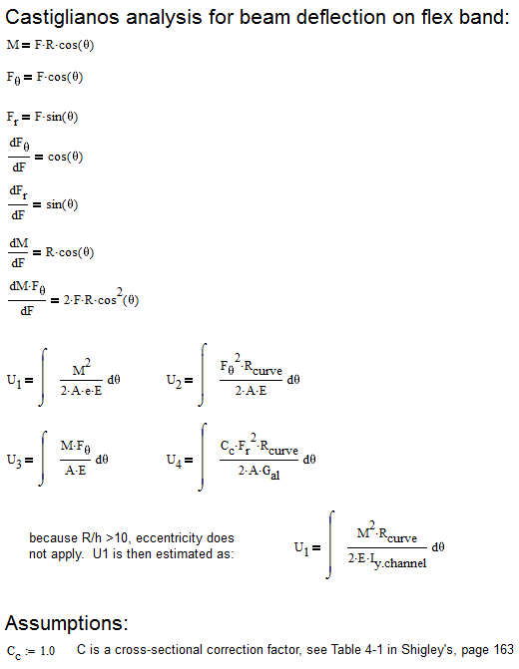

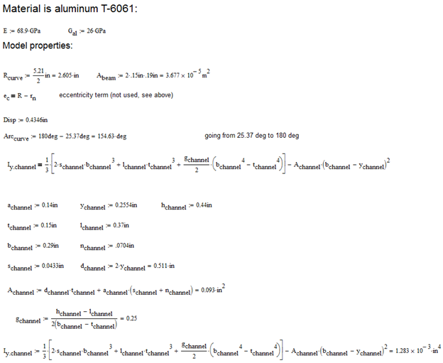

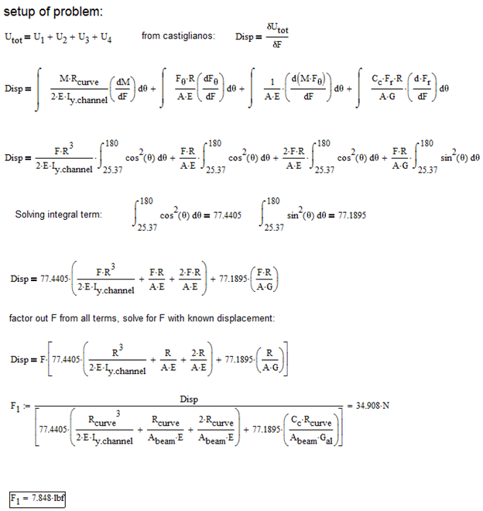

# Calculating for yield of designed clamping area

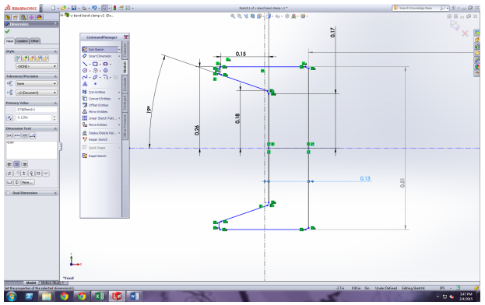

Figure 1E- Cross section of v-band.

Summary: The objective of this analysis is to find the minimum wall thickness of the V-band to withstand the forces outlined in the PDS. The PDS states that the device needs to withstand a minimum tensile force of 250 lbf.

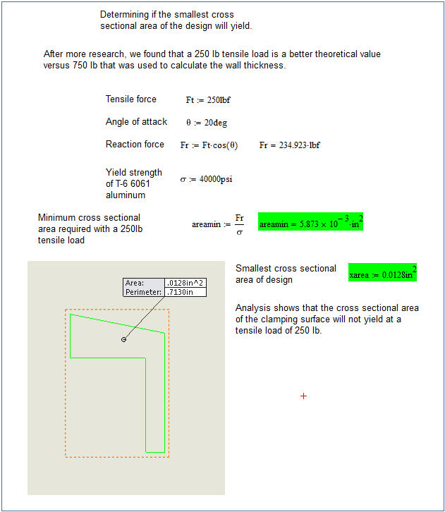

# 

# APPENDIX F: Assembly Instructions

**Sled Sub-Assembly**

|  |  |  |
| --- | --- | --- |
| Part | Qty | Description |
| 1 | 1 | Sled |
| 2 | 2 | 1/8" ID x 3/8" OD Bearing |
| 3 | 1 | 1/4-16 x .25" ACME Nut |
| 4 | 1 | 6-32 Set Screw |

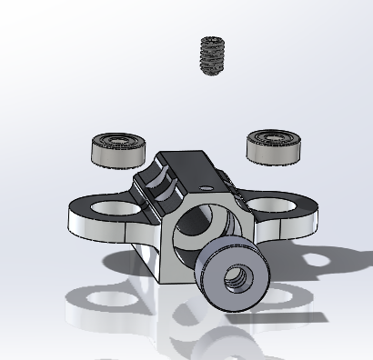

Instructions:

1. Using an arbor press, press both bearings into the holes along the side of the sled. Press the ¼-16 ACME Nut into the counterbore on the front surface of the sled.
2. Place some Loctite onto the threads of the 6-32 Set Screw. Screw the set screw through the hole located in the top of the sled until it is snug against the ¼-16 ACME Nut.

**Baseplate Sub-Assembly**

|  |  |  |
| --- | --- | --- |
| Part | Qty | Description |
| 1 | 1 | Baseplate |
| 2 | 3 | 2-56 x .5" Phillips Panhead Machine Screws |
| 3 | 2 | Limit Switches |
| 4 | 4 | #3 x 1" Socket Head Cap Screws |
| 5 | 8 | #3 Nylon Lock Nuts |
| 6 | 8 | #3 Washers |
| 7 | 1 | 7mm x 60mm Precision Guide Rail |
| 8 | 1 | Modular Baseplate Stem |

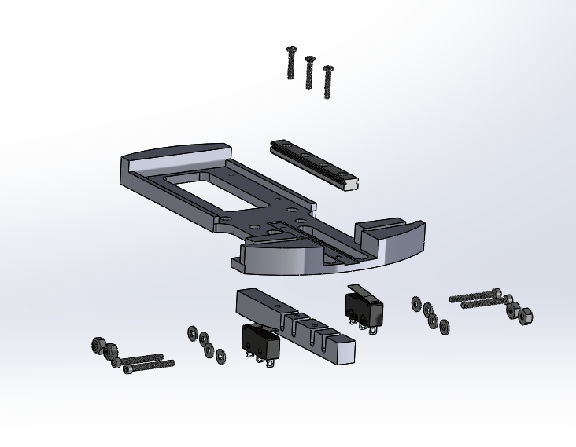

Instructions:

1. Slide the 7mm Precision Guide Rail into the slot for the guide rail.
2. Place Modular Baseplate Stem on the bottom of the baseplate and attach the stem and rail using the 3 2-56 x .5” Phillips Panhead screws.
3. Align the rear limit switch with the left hand side of the Modular Baseplate Stem grooves as shown.
4. Thread two #3 screws with washers through the limit switch and Stem grooves. Place a second set of washers on the exposed end of the screws.
5. Thread two #3 Nylon Lock Nuts over the exposed ends of the screws. Tighten the nuts down most of the way, but leave some play in the limit switches for later adjustment.
6. Repeat steps 3 through 5 for the front limit switch, but with the switch facing the oposite way and in with the switch aligned to the forward most groove set of the Modular Baseplate Stem.

**Drive Train Sub-Assembly**

|  |  |  |
| --- | --- | --- |
| Part | QTY | Description |
| 1 | 1 | Journal |
| 2 | 2 | INA 0.25 ID x 0.688 OD Needle Thrust Bearings |
| 3 | 2 | INA 0.25 ID x 0.688 OD Thrust Washers |
| 4 | 1 | 0.125" x 0.125" Shaft Coupler |
| 5 | 1 | 0.25" Shaft Collar |
| 6 | 1 | 1/4-16 x 2.75" Length ACME Power Screw |

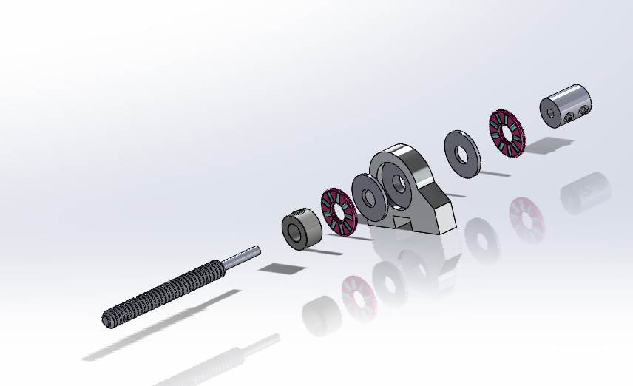

Instructions:

1. Seat one Thrust Washer and one Needle Thrust Bearing into the Journal.
2. Seat the 0.25” Collar onto the ACME Power screw approximately 2.25” down the shaft from the unturned side.
3. Slide the power screw through the journal and bearing assembly until the 0.25” Collar is seated against the Needle Thrust Bearing.
4. Repeat step one for the other side of the Journal.
5. Seat the 0.125” to 0.125” Shaft Coupler over the turned side of the ¼-16 ACME Power Screw until the Shaft Coupler makes contact with the second Needle Thrust Bearing.
6. Tighten down all set screws. Apply Loctite to all threaded joints if connections feel loose or worn.

**Motor Mount Sub-Assembly:**

|  |  |  |
| --- | --- | --- |
| Part | QTY | Description |
| 1 | 1 | BaneBots RS-550 Brushed DC Motor |
| 2 | 1 | Motor Mounting Bracket |
| 3 | 2 | M3 x 6mm Machine Screws |

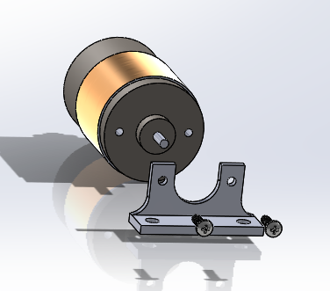

Instructions:

1. Align the metric 3 mounting holes on the BaneBots RS-550 DC motor with the mounting holes on the Motor Mounting Bracket.
2. Screw the Motor Mounting Bracket to the DC motor with the two M3 x 6mm Machine Screws.

**Actuator Sub-Assembly:**

|  |  |  |
| --- | --- | --- |
| Part | QTY | Description |
| 1 | 1 | Motor Mount Sub-Assembly |
| 2 | 1 | Power Train Sub-Assembly |
| 3 | 2 | 10-32 x 5/8" Length Machine Screws |
| 4 | 2 | 10-32 x 3/8" Length Machine Screws |
| 5 | 1 | 7mm Precision Carriage |
| 6 | 4 | M2 x 8mm Socket Headcap Screws |
| 7 | 2 | 10-32 Nylon Lock Nuts |
| 8 | 1 | Baseplate Sub-Assembly |
| 9 | 1 | Sled Sub-Assembly |

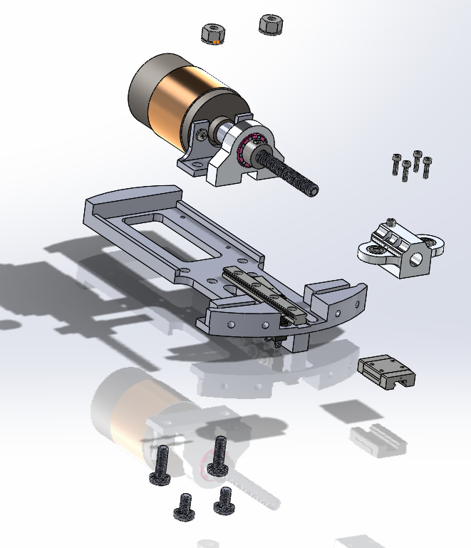

Instructions:

1. Screw the Sled Sub-Assembly onto the 7mm Precision Carriage (5) using the M2 x 8mm socket headcap screws (6).
2. Slide the motor shaft into the free side of the shaft coupler (located on the drive train sub-assembly).
3. align the 10-32 threaded mounting holes of both the motor mount and the journal with the 10-32 mounting holes on the baseplate.
4. Thread the ⅜” length 10-32 screws into the Journal. Leave them Hand tight for now.
5. Slide the ⅝” length 10-32 screws through the motor mount holes and thread the 10-32 nylon lock nuts over the top of the screws. Leave them hand tight for now.
6. Depress the lever of the front limit switch with a flathead screw driver or small allen key.
7. With the limit switch lever depressed, slide the sled and 7mm carriage assembly onto the 7mm precision rail. **CAUTION: the limit switch can be easily damaged in this step. Additionally, the 7mm carriage contains dozens of 1/32” ball bearings in the bottom of it which can easily come out if the assembly is jarred. Take care in this step and be careful not to damage the components.**
8. With the limit switch depressed and the sled assembly partially on the rail, hand turn the power screw until the entire sled assembly is on the rail and has cleared the front limit switch.
9. Tighten all screws and nuts using the appropriate tools. Tighten the set screws on the shaft coupler last. When tightening screws on the shaft coupler, rotate the power screw several times to ensure that the screw is aligned well and does not have any rough spots throughout its rotation.

**Attaching the V-band to the Actuator Sub-Assembly:**

|  |  |  |
| --- | --- | --- |
| Part | QTY | Description |
| 1 | 1 | Actuator Sub-Assembly |
| 2 | 2 | Dowel Pin Size 1 |
| 3 | 2 | Dowel Pin Size 2 |
| 4 | 8 | 1/8" E Clips |
| 5 | 1 | V-Band |
| 6 | 2 | 0.8” Relative Motion Arms |

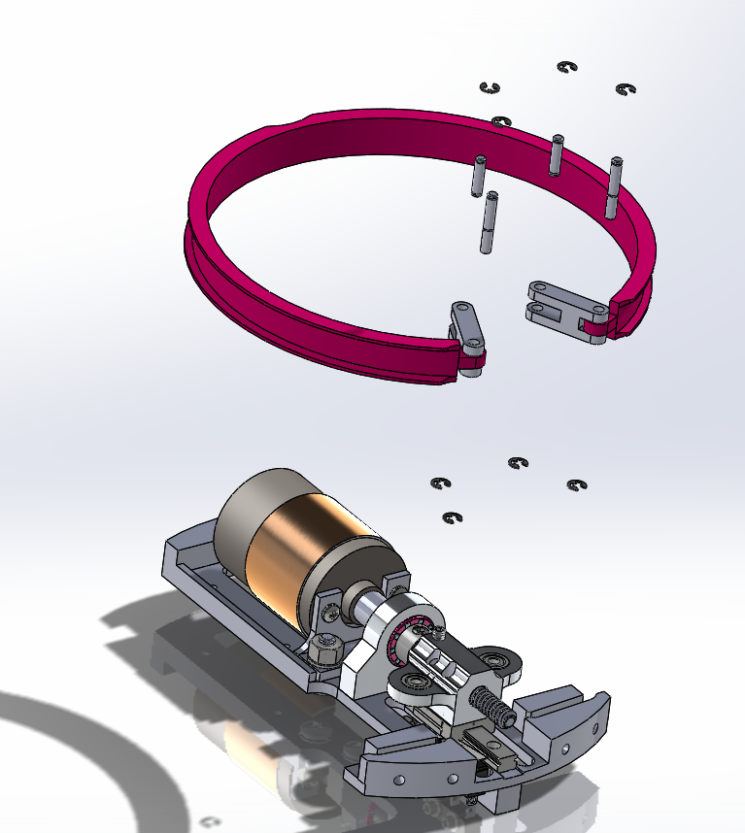

Instructions:

1. Attach one E Clip to the top side of each of the Size 2 Dowel Pins (the longer of the two).
2. Slide the front side (the front side has the shorter groove) of one of the relative motion arms over the connection tab of the V-band.
3. Slide one of the Size 2 Dowel Pins through the relative motion arm and V-band tab.
4. repeat steps 2 and 3 for the other relative motion arm and V-band tab.
5. Flip the V-band over and attach a second E Clip to the bottom of the dowel pin size 2.
6. Slide the V-band and relative motion arm assembly over the actuator sub-assembly. The exposed length of the dowel pins should seat into the guide rails of the baseplate.
7. Rotate the back side of the relative motion arms until the second set of holes lines up with the bearing holes in the sled.
8. Attach an E Clip to one side of each of the dowel pin size 1 pins.
9. Slide the pins through the relative motion arms and bearings.
10. Flip the assembly over and attach the last two E clips the the bottom side of the dowel pin size 1. Note: the bottom E Clips are very difficult to seat over the dowel pins and will test the patience of any mortal.

**Male Coupling Ring and Wave Spring Sub-Assembly**

|  |  |  |
| --- | --- | --- |
| Part | QTY | Description |
| 1 | 3 | Indexing Tabs |
| 2 | 1 | Male Coupling Ring |
| 3 | 1 | Wave Spring (Smalley Springs SSR-0637) |
| 4 | 3 | 4-40 x 0.25" Tapered Machine Screws |

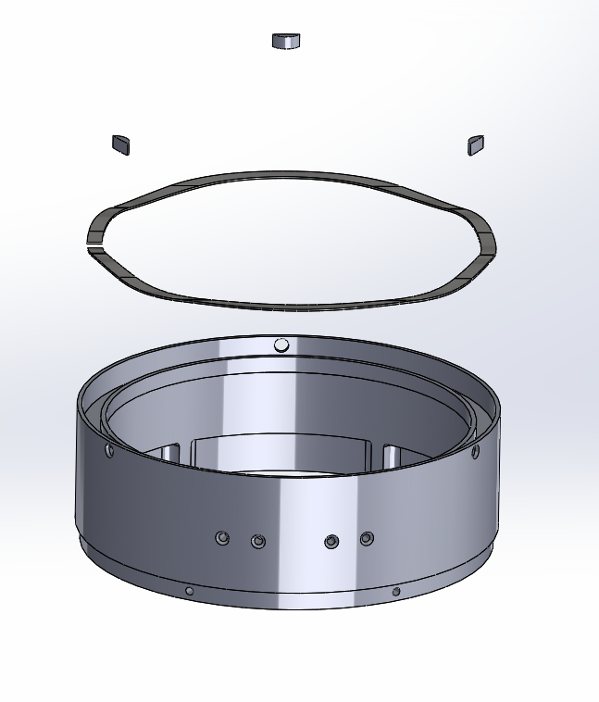

Instructions:

1. Place the wave spring in the groove of the male coupling ring.
2. Place the indexing tabs over the wave spring and line them up with the three holes in the side wall of the coupling ring.
3. Screw the 4-40 x 0.25” tapered machine screws into the side wall of the coupling ring. This will secure the wave spring into the provided groove.

**Seating the Actuator and V-band Assembly into the Coupling Ring**

The actuator and V-band assembly is fixed to the male coupling ring and wave spring assembly by seven 4-40 tapered machine screws. When seating the actuator assembly inside the male coupling ring assembly, gently thread all screws in until they are hand tight, alternating between the front four screws and back three screws. Gently tighten all screws down with an allen key only after all screws have been seated and are hand tight. Connect all electronics at this time. The actuator and male coupling ring assembly is now flight ready, and can be mated with the female coupling ring.

**Appendix G: Drawings**

